

**Facilitators Information**

**Name of NQP: ________________________________**

**Has your NQP been allocated a Flying Start facilitator? If not, please allocate a facilitator for NQP.**

**Name of Facilitator:______________________________ (please ensure facilitator is given this sheet).**

**What is the role of the Flying Start facilitator?** To support and guide learning, and confirming the NQP has met the learning outcomes for the programme.

**Who can be a Flying Start facilitator?** An experienced nurse, midwife or AHP colleague.

**Who can offer support to the facilitators:** Line Managers, PEFs/CHEFs/AHP PELs.

**Are all NQPs required to undertake and complete Flying Start programme?** Yes. This is a Scottish Government requirement that all NQPs undertake and complete the programme, it is also NHS Highland policy.

**How long do NQPs have to complete the programme?** Within12 months.

**Is the NQP required to work with facilitator at all times?** No, not all of the time. It is important that the NQP works as part of the team and seeks feedback/learning opportunities within the working environment, with other team members.

**What are the learning outcomes for the 4 Pillars of Practice for Flying Start?**

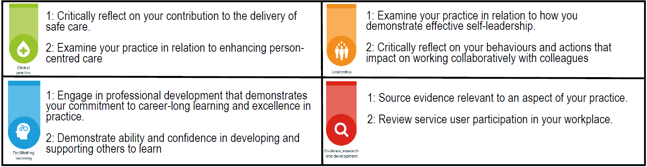

Further information can be found in the Flying Start Definitive Guide: <https://learn.nes.nhs.scot/735/flying-start-nhs>

**What evidence should NQP be providing and discussing with facilitator to achieve learning outcomes**. Professional/reflective discussions, feedback, learning activities undertaken, identification of self development needs. This evidence can then be used towards NMC Revalidation/HCPC Standards. There is also The Graduate Programme run by NHS Highland that complements the learning within Flying Start and all NQP are invited to join the programme.

**Who confirms completion of Flying Start programme for NQP?** The facilitator confirms completion using the link, which the NQP initiates via TURAS. This should be done following review of evidence for each individual pillar.

**Who should be informed of completion of programme?** Line Managers, PEFs/CHEFs/AHP PELs. Completed certificate for the programme can be forwarded by NQP to your PEF/CHEF, and the record is then updated to reflect completion.

**Date of initial meeting: __________________**

**Date clinical pillars evidence reviewed: Pillar 1: __________ Pillar 2: __________**

**Pillar 3: __________ Pillar 4: _________**

**Date clinical pillars confirmed: Pillar 1:___________ Pillar 2: ___________**

**Pillar 3: ___________ Pillar 4: ___________**

**Completion certificate forwarded to PEF/CHEF/AHP PEL by NQP: __________________ Date: _________**