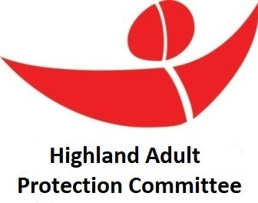

Social Work ASP Case Record Audit Report by Molly Gilbert, Principal Officer: Adult Protection

APC June 2025: Item 9

Risk Assessment and Protection Planning Audit

1. **Introduction**

Case Reviews and case file audits are a critical part of continuous improvement, a key component of monitoring, self-evaluation, and quality assurance, establishing standards of practice, and learning and improvement. A group of 7 readers comprised of experienced Social Work Team Managers/Nominated Officers, Principal Officers and Social Workers undertook an audit of social work case records for Adult Support and Protection (ASP) on 25th April 2025. The focus of the Audit was to determine the quality of both risk assessments and protection plans on file for individuals in the sample. Readers used an adapted “Scrutiny of Adult Protection Record Template” originally used by the Care Inspectorate for inspections and the Care Inspectorate Quality Framework for Adult Support and Protection ([view here)](https://www.careinspectorate.com/images/documents/7788/Quality%20framework%20for%20ASP%20September%202024.pdf).   
The methodology was, then, an evaluation by social workers of the records and the outcomes for individuals at risk of harm. The findings therefore need to be seen as complementary to any information collected directly from adults and carers who have been involved in Adult Protection core processes about their experiences.

In addition to the audit, we sent a survey to Social Workers who are Council Officers/Nominated Officers to obtain their views regarding the quality of risk assessments and protection plans in the case files they work with. There was a small return on this survey of 12 practitioners – the full [results can be viewed here.](https://forms.office.com/Pages/AnalysisPage.aspx?AnalyzerToken=hiy9CApEsTdJA1B1ZWPStE4aXkWmzgxE&id=veDvEDCgykuAnLXmdF5JmnNfQe7AvQ9LmaEdztPKbolUNDYyTlROQUtSMTdUN0JPWEQwT0w3MDM1Ui4u)

This report presents an analysis of the audit and questionnaire.  The purpose of this analysis is to evaluate the effectiveness of current practices in risk assessment, protection planning, and outcomes for adults at risk. The findings aim to inform the work of the Adult Protection Committee (APC) and continuous improvement in ASP practices across the service.

1. **Demographics**

This section outlines the demographic profile of the individuals whose cases were audited.

Total number of cases reviewed: **27**

Cases audited were a randomised sample of ASP3's (investigations) completed between April 2024 and March 2025 with an outcome of 'yes - proposed case conference to be arranged' and all ASP4's (reviews) completed between April 2024 and March 2025 with an outcome of 'yes - protection plan to be actioned'. All files were taken from CareFirst.

* Age distribution:

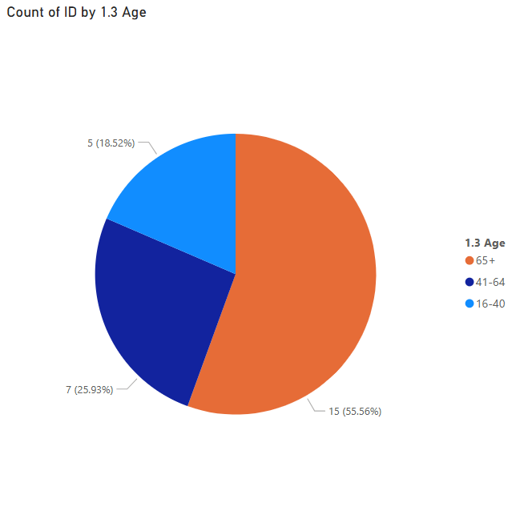

* Gender breakdown

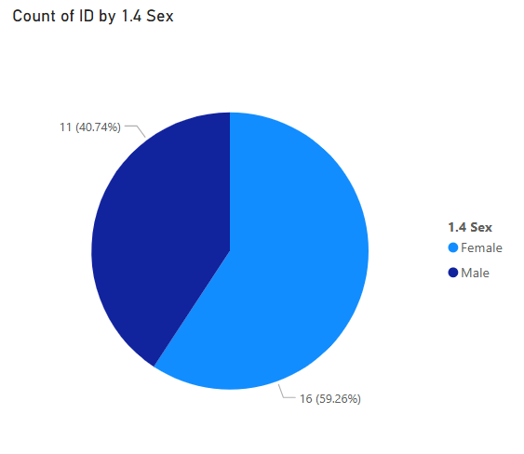

1. **Risk Assessment**

This section evaluates how risk was identified, assessed, and recorded in the audited cases.

* Percentage of cases audited with a completed risk assessment: **100%**
* Quality of risk assessments:

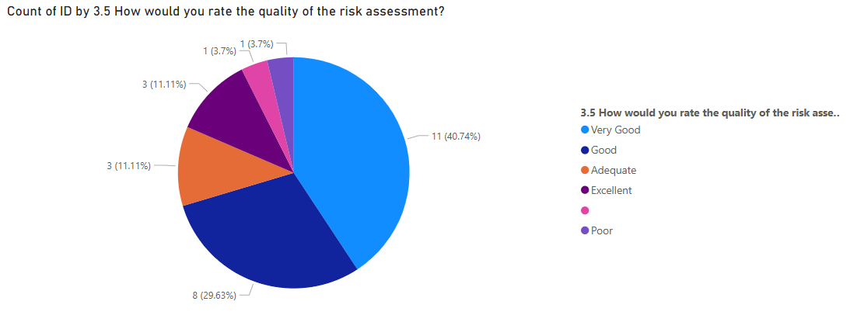

* Questionnaire Results:

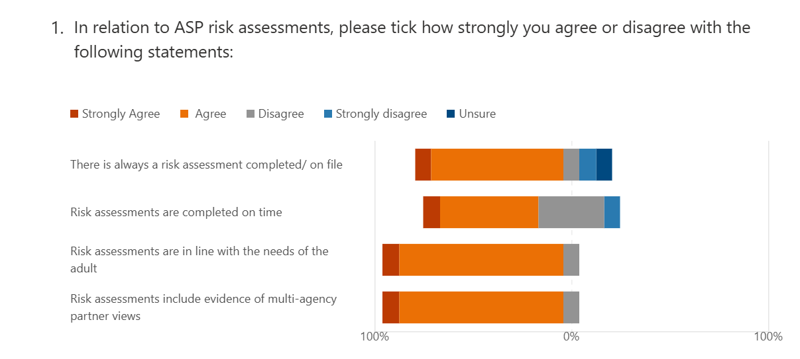

* Comments from audit readers on risk assessments:
* Key Strengths:
* “Lots of information from a multi-disciplinary network. Clear chronology to support assessment.”
* “Advocacy was offered at the interview stage. Chronology has been completed detailing recent and relevant information about incidents/risk of harm.”
* “Accurate, relevant and appropriate information Clear analysis / impact of self-neglect and wider risks identified.”
* Needs Improvement:
* “Lack of analysis of risk. i.e impact of mental health on alcohol use.”
* “Lack of analysis of risk- in that section of the assessment more descriptive information was recorded.”
* “Analysis could be strengthened and pattern noted more clearly – re times of day.”
* Feedback from staff questionnaire:
* Key Strengths:
* “The ability to email the concern hub or speak directly to the PPU if needed. In addition I can speak to a NO from health if need be. Staff are more confident in terms of thinking things through in relation to the three point criteria.”
* “As risk assessment is part of ASP3 document, it ensures one is always completed which I feel works really well. There is lots of prompts in the ASP3 document to ensure the risk assessment covers all concerns.”
* Needs Improvement:
* “Skill and confidence improvement in aiming for objective risk assessment for all parties involved in risk assessing. Commitment to a shared process and support with the logging of documentation across the partnership. Responsibility often falls to SW to risk assess in isolation, where a shared approach is required.”
* “Text boxes are restricted which means you cannot always document all communication with other agencies.”
* Summary of findings

The audit reveals a generally strong commitment to conducting risk assessments across adult protection cases. All cases had a risk assessment on file, and the majority were completed in a timely manner. There was consistent evidence of multi-agency involvement, particularly from police and health services, which enriched the assessments with diverse perspectives. This collaborative approach is a key strength.

There were some excellent examples of good practice in risk assessment and analysis demonstrated, but the quality of risk assessments did vary. While many were rated as “Very Good” or “Excellent,” a notable proportion were only “Adequate” or “Poor.” Common issues included a lack of analytical depth, over-reliance on descriptive chronologies, and insufficient exploration of protective factors. In some cases, the assessments failed to clearly articulate the immediacy or severity of risk, or to reflect the adult’s own views and capacity. These gaps suggest a need for more robust inclusion of analytical writing and risk formulation to be included in the Level 3 Council Officer training or for this to be picked up as a separate learning and development need.

Encouragingly, most concerns regarding protection-type risks were reported as being adequately addressed. Where they were not, the reasons often related to systemic delays, unsuccessful attempts to engage the adult, or unresolved or ongoing capacity issues. This highlights the complexity of adult protection work and the importance of balancing protection interventions with the needs and wishes of the person.

1. **Protection Planning**

This section reviews the quality and effectiveness of protection plans developed in response to identified risks.

* Percentage of cases with a protection plan in place:

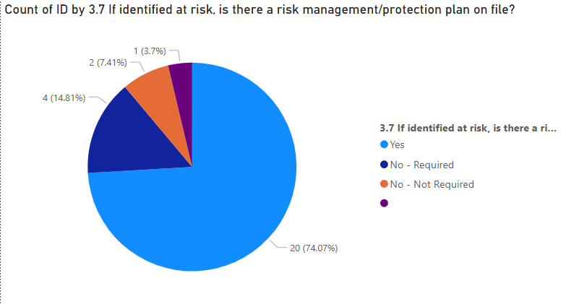

* Quality of Protection Plan:

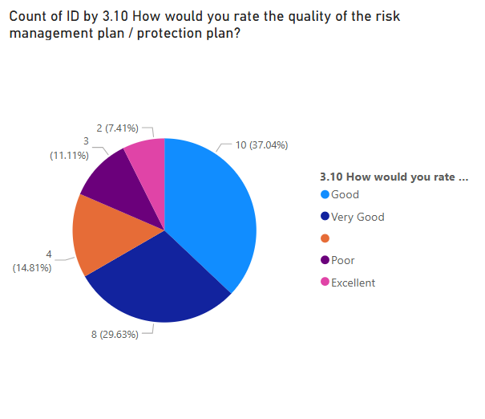

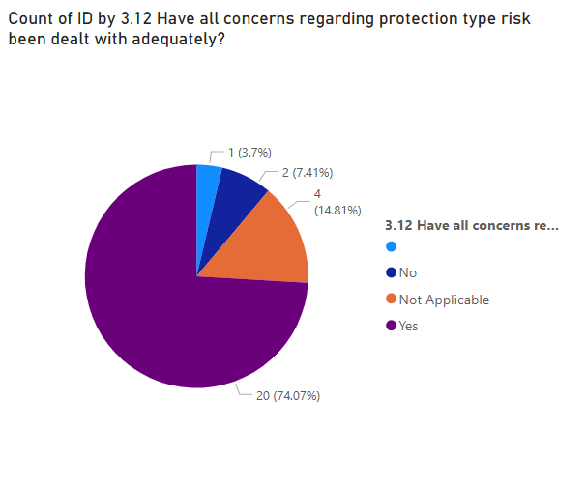

* Questionnaire Results:

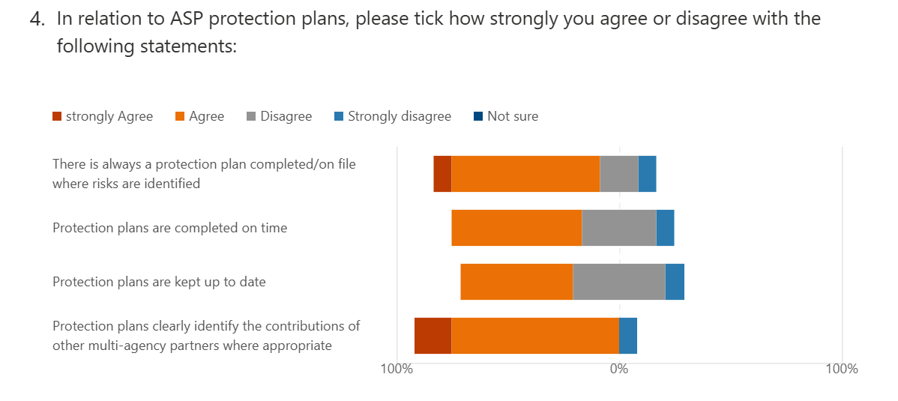

* Comments from audit readers on protection plans:
* Key Strengths:
* Actions are shared across disciplines. Clear timescales attached and intended outcomes recorded clearly. Thorough.”
* “SMART goals – clear timescales - relevant actions in relation to risk.”
* “Focuses on the key areas of risk- namely around sexual exploitation. Included actions for other professionals and family.”
* Needs Improvement:
* “Try to avoid vague timescales. Ensure intended outcomes are person centred. Would like to see the outcomes being more specific to what the person sees them to be.”
* “A bit too long in places and could have been more concise. Would have like to have seen the protection plan possibly targeting the higher risks first.”
* “Intended outcomes need to be person centred. ‘Self-explanatory’ is not appropriate. Outcomes need to be able to be measured.”

* Feedback from staff questionnaire:
* Key Strengths:
* Willingness from Professionals and Providers to formulate plans that have the interests of the individual (The adult at risk) at heart.
* Protection plan agreed with all professionals at meeting.
* Needs Improvement:
* The style & format of how the plan is written could be more overtly linked to the presenting risk. Each partner agency or formal/informal support should be clear what they are able to offer and for them to have made the link /understand what the desired or agreed outcome is and how this alters the risk .This should have already been discussed in a risk context with the focus person and relevant family /carers and what they can offer to support /reduce/address with an understandable linked outcome.
* Plans are often static and not dynamic.
* Summary of findings

Protection plans were present in nearly all cases where risk was identified, and most were up to date. The best examples demonstrated clear, SMART (Specific, Measurable, Achievable, Relevant, Time-bound) actions, with responsibilities assigned and timescales defined and with a clear link back to identified risks within the risk assessment. These plans often reflected the adult’s wishes and were proportionate to the level of risk, showing a strong person-centred ethos.

However, variability in quality was evident. Some plans lacked specificity, with vague actions and undefined outcomes. In a few cases, the protection plan did not fully align with the risks identified in the assessment and lacked contingency planning. There were also instances where the plan was embedded in case conference minutes rather than recorded in a structured format, making it harder to monitor progress. Feedback also highlighted that Case Conference minutes (which form the ASP4 Protection Plan) can have significant delays and there was not an explanation in the case notes to account for this. That means that an individual is clearly identified as ‘at risk’ and the Case Conference may have taken place, but there is nothing within the case file to reflect this. This is a gap within the ASP process which needs addressing, particularly as there were clear and timely risk assessments on file, but then a ‘drop off’ when it came to protection planning.

Multi-agency contributions were generally well-documented, but there were missed opportunities for deeper engagement with health professionals, housing, or advocacy services in some cases.

1. **Outcomes**

This section assesses the outcomes for individuals following intervention.

* Improvement in safety and wellbeing:

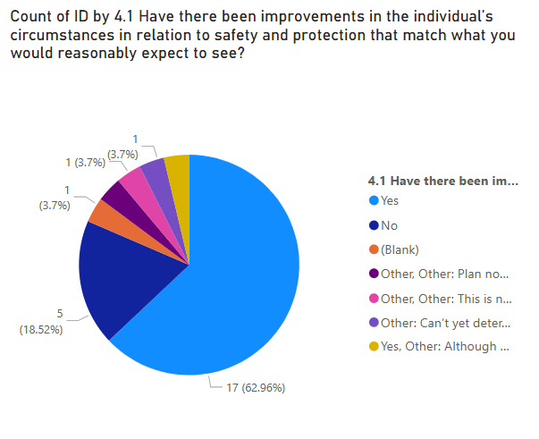

55% of individuals experienced improvement in circumstances following the Protection Plan implementation

* Comments from audit readers on outcomes:
* Key Strengths:
* “Initial action taken through a multi-agency approach to deliver a co-ordinated response to protect the individual from harm.”
* “Proportionate and person centred as the plan and outcome is in line with the individuals wishes and ensures support around key issues as well as monitoring risks but without the requirement for ASP to continue (least restrictive).”
* “Multi-agency working between social work, health services, care providers and day centre supported in addressing health needs, improving mobility, improving dietary intake and social inclusion.”
* Needs Improvement:
* “Whilst not captured in ASP, case notes state that client had numerous engagements with addictions services but did not engage – this may be personal choice or lack of a service which can adapt to her needs.”
* “Further recognition should have been given to on-going risks that were raised in the review case conference in relation to the decision to close the ASP – it felt a little disjointed/didn’t show the full decision-making process.”
* “Clearer outcomes required in the protection planning stage. The clients voice was not strong in the assessment.”

1. **Conclusion**

The audit paints a picture of a dedicated workforce for ASP operating within a complex and often challenging landscape. There is clear evidence of good practice, particularly in multi-agency collaboration, timely interventions for risk, and analysis and evidenced decision making in supporting the person. Many adults experienced improved safety and wellbeing as a result of the ASP process.

However, the audit also highlights inconsistencies in the quality of documentation, analysis, and planning. While procedural compliance is high, the depth and clarity of professional reasoning varies. This can impact the effectiveness of interventions and in particular protection planning activity. The audit also underscores the importance of capturing the adult’s voice and ensuring that plans are not only protective but also in line with the principles of the ASP Act, person-centred and trauma informed.

* Key recommendations for improvement:

1. **Strengthen Risk Analysis Skills**: Provide targeted training (or include within Level 3) on risk analysis and outcome-focused report writing to enhance the quality of assessments and plans.
2. **Standardise Protection Plans**: Provide more in-depth training and guidance for protection plans to ensure clarity, consistency, and improved quality as well as improved adherence to timescales.
3. **Enhance Multi-Agency Engagement**: Formalise expectations for contributions from health, housing, and advocacy partners, especially in complex cases.
4. **Address Systemic Barriers**: Identify and escalate delays in service provision, capacity assessments, and case recording that hinder timely protective actions.
5. **Improve Processes**: Review and update the Case Conference and Protection Planning procedures in line with the identified areas for improvement.
6. **Embed Reflective Practice**: Promote professional reflective supervision, leadership and peer review to support continuous improvement in adult protection work.