How to help me communicate

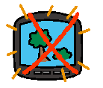
Turn off any background noise.

Make me feel at ease. Don’t rush me.


Show me you have time to listen
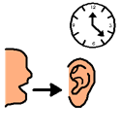

How to help me express myself
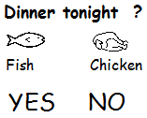
Give me a limited choice of possible answers. You might want to write down or draw the choices.
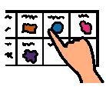

Watch my facial expression and gestures as these might tell you more about what I mean.
See if there is something in my book that will help me.
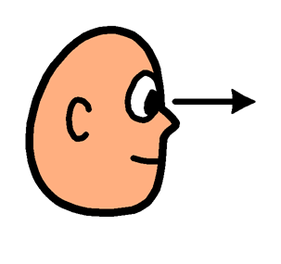

How to help me understand
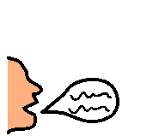
Write down important words as you are speaking.
Use a prop or a photo to help me understand what you are speaking about.
Try to give me one piece of information at a time.
You might need to repeat what you’ve said and then remind me again later.



Use natural gesture to help me follow.
Draw a picture or find something in my book that might help you explain.
