My Working Life

My Working Life
I left school when I was 15 years old. On leaving school I worked in the office at British Home stores. Then I went to work in Grandholm Mill, to work on the looms.


British Home Stores

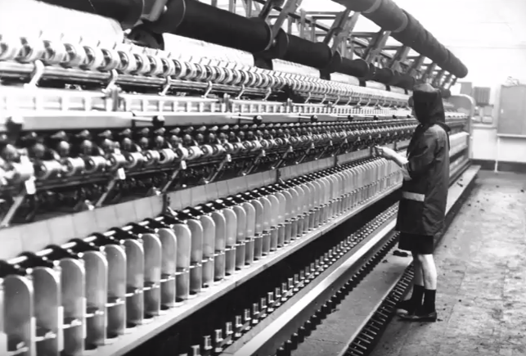
Looms at Grandholm Mill

When I was 20yrs old I moved to Germany to work in the Naafi shops on the Army bases, they supplied goods to military services personnel and their families.


It was whilst working in Germany that I met my husband, he was based there with the army. During his time in the army we lived in Germany, Hong Kong, Cyprus and England. He was posted for 2 years to each place.


Hong Kong


Germany


Cyprus

