QI Team Support Checklist | 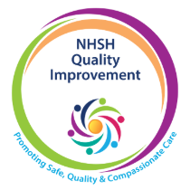
Once you have checked that the work you want to do will benefit from a QI approach (What is Quality Improvement ) this checklist will help you assess whether you have the essential requirements of a Quality Improvement project in place.

Once this checklist is complete if you do not have the QI expertise in your team, the QI Team can help by providing coaching & support to guide you through the Quality Improvement Journey and support you to use QI tools creating structure around your project.

Please note your team is always responsible for; co-ordinating the project team to attend improvement meetings, running audits and tests of change and writing project reports and updates
Before requesting QI support, please provide the following information:
Project set up
Who will be leading this project?

Please explain what your problem is (100 words)?

Confirm the names of the multidisciplinary team members engaged with this project to ensure success. (By naming them you confirm they have committed time to this project)

What day & time will you meet to review and progress of the project? (All listed above should attend, minimum weekly)
Running your project
Which staff have you identified as willing to test changes?

How will you gather the team together to discuss new PDSA tests and subsequent feedback (time for a quick daily update)
Who will collect data?

How will you regularly share updates on the project with the team? Consider shift patterns, remote working and communicating across all professional groups
Which member of the senior leadership team would you go to if you needed help to remove barriers to progress?

Please confirm how many people in your area are QI trained and list them here:

Please return this form via email to nhsh.qualityimprovement@nhs.scot and we will assess your request.

