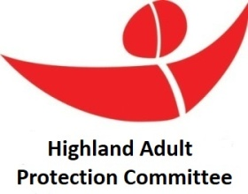

**Highland Adult Support and Protection Learning Review Process**

**Notification Form**

**To be reviewed by the ASP Learning Review Governance Group of the HAPC (+20 days)**

**Request for Information Form**

**Relevant agencies provide brief** **account of involvement and**

**some very initial reflections (+10 days)**

**Consideration of information gathered**

**by the ASP Learning Review Governance Group of the HAPC (+10 days)**

**Decision made by the ASP Learning Review Governance Group of the HAPC**

**Decision not to proceed with Learning Review**

**Decision to proceed with Learning Review**

**Recording and Communicating the decision:**

* **Inform the Highland Adult Protection Committee for ratification**
* **Discussion at Chief Officers’ Group**
* **Record Decision on SharePoint List**
* **Notification Response to referrer**
* **Notifying the Care Inspectorate**
* **Communication and Media approach (where relevant)**

**Consider alternative approach for learning** (if the decision is not to undertake a Learning Review):

* **Is an internal agency review necessary?**
* **Are there any improvement actions for the HAPC or other learning to be shared?**
* **Is an ILO (initial learning opportunity) needed?**

**Learning Review Report** for HAPC and COG; also send to CI

**Action Plan for Dissemination of Learning**

**Learning Review undertaken**

**Learning Review arrangements:**

* **Lead reviewer(s) identified and Learning Review Team set up**
* **Family Liaison Strategy**
* **Consideration of any parallel reviews**