My Hobbies & Interests
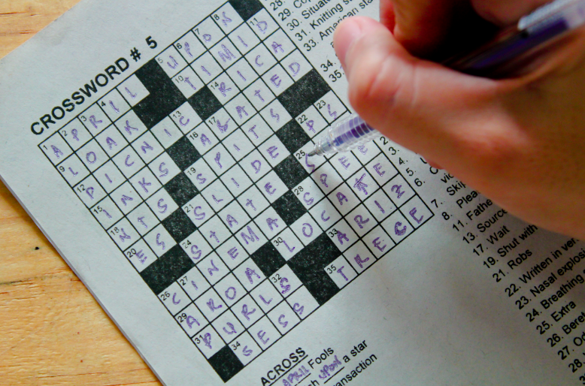
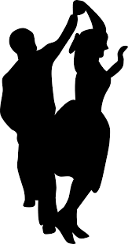

My Interests

I enjoyed doing crosswords and other puzzles like Sudoku.
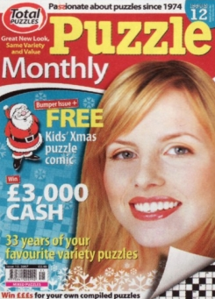
I buy the Puzzle Monthly magazine to do the crosswords.

When I was younger I enjoyed sewing.
I never made my own clothes but I
could alter a hem and do simple repairs
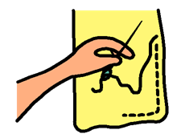

I still enjoy watching TV. Some of my favourite programmes are: The Chase, Vera and Taggart.

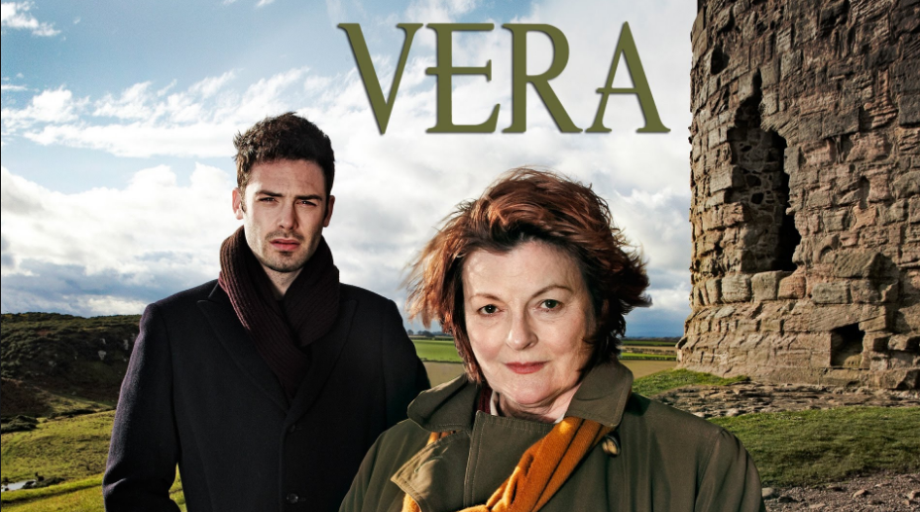

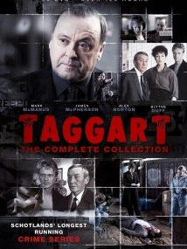

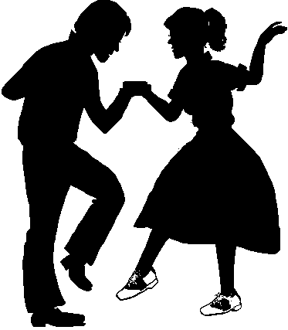
I enjoyed dancing when I was younger and I still enjoy a dance, to the right kind of music.

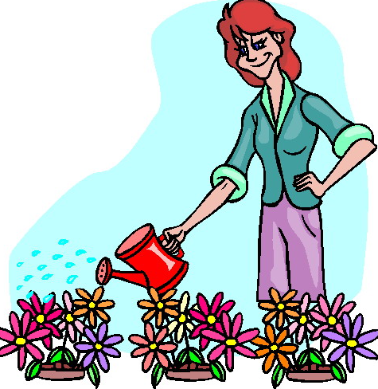

I used to enjoy gardening when I was younger.

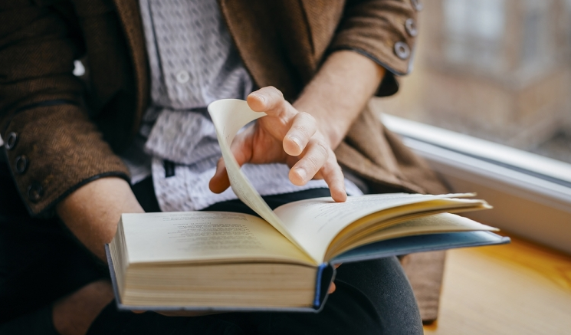
I enjoyed reading books especially thriller and crime fiction.

Holidays
My husband and I have had many lovely holidays to several places; Crieff, Lossiemouth and Skye. My friend and I used to go to Spain on holiday together.

Spain

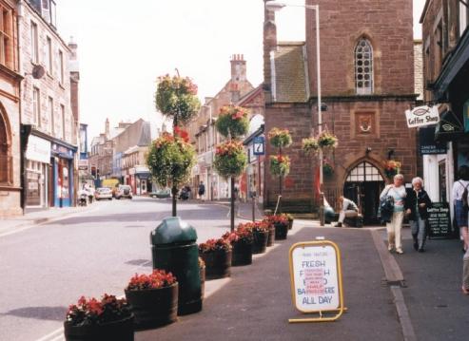
Crieff

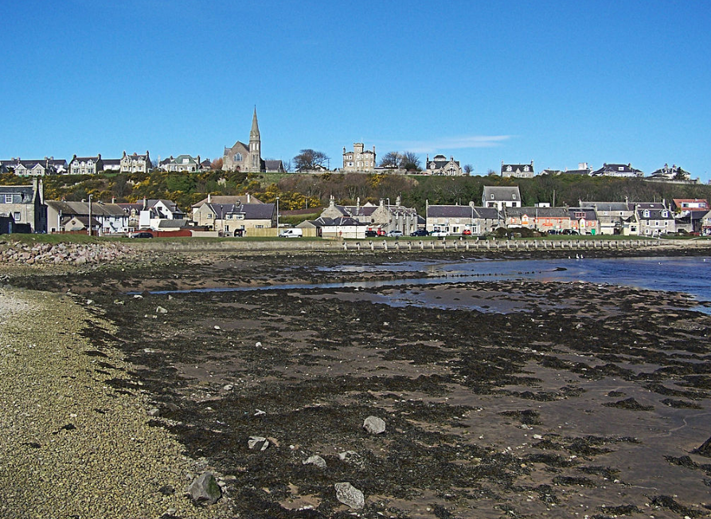
Lossiemouth

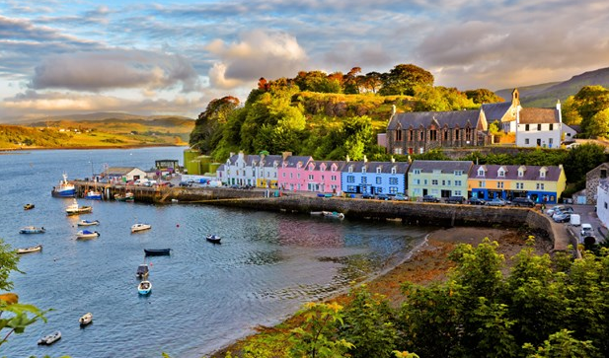
Skye

