Me & My Family
Insert personal photo of patient & family if applicable
About Me
I was born on the date month year at birthplace. My parents were names. I have 3 brothers and 2 sisters. My brothers are names. My sisters are names

Some other people born in the same year as me include;
Sir Paul McCartney
Billy Connolly
Barbra Streisand
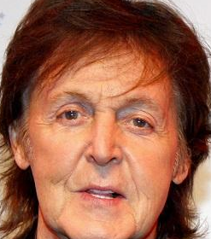
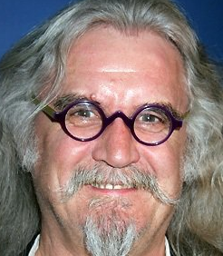


photo of person possibly when they were a child or young adult

My Family

My dad was a farm hand then he served in the army during WW2. After the war he worked as a dreyman, delivering barrels of beer to pubs.
When I was young we lived at places, addresses. Any information that patient would like included because it is important to them and/or is useful to give staff etc an idea of the person to enable conversation. Parents, siblings, cousins grandparents names always useful

Photos of house, street, place lived in
preferably patients own photos or if none available stock images downloaded from internet (check copyright)

Patients education from primary to higher. Any particular Subjects they liked/were good at

Photo of schools attended. Probably need to get from internet.

Photo of schools attended. Probably need to get from internet.

My dad was stationed in Paris once it was liberated by the allies.
My dad visited France again in 1967, he took this photo of Paris.

Photo dad took

As I said I have 3 brothers and 2 sisters. My brothers names are older than me and my two younger sisters names. brother is married to sister-in-law and they have a son and daughter. brother sadly passed away 5 years ago. Sister visits me every Wednesday and we go out for a fly cup to Dobbies. Sister and husband live in Portsmouth, sister had a stroke and is unable to travel so sadly I don’t see them now.
Family photos
Family photos
Family photos
These are some family photos of my siblings, nieces, nephews and great-nieces & great- nephews.
Family photos
Family photos
Family photos
Family photos

My husband Abe and I met when he was stationed in Germany with the army. I had went to work in the NAAFI shops there. We married on August 22nd 1963

Wedding photo

Abe is a retired Storeman. He worked for company name and then company name in Altens. We live in place.

Photos of company

Abe and I have a son; Jack. My Son and his wife live in Kincorth. They are both taxi drivers and visit me regularly.
They have a daughter Abigail she is 27, she is married to Simon and they have a new baby son Findlay. I love it when my granddaughter brings my great-grandson to visit me. Abigail comes over once a week with Findlay to visit, if it’s nice weather we sit outside in the garden.

Photos of family

Photos of family

Photos of family

My Friends

This photo was taken in Cyprus. We lived there for a while when Abe was in the Army and Duncan was in the RAF. Me with my friends Annabel and Duncan, Ann is holding Jack.
Duncan and Annabel live in Alford now. If the weather is good Abe will drive me over to visit them.

photo

I also remain friends with Jane Spade. Jane was engaged to my brother at one time and I have remained friends with her. She lives in Elgin.

